- March’s jump in UK CPI inflation provided the first official evidence of the inflationary impact of the US/Israel-Iran war, with the increase entirely driven by higher petrol and heating oil prices. But timelier business surveys for April suggest that the pickup in inflationary pressures has already started to broaden out from fuel prices to a wider variety of goods and services.
- The week’s labour market data reported a further cooling in pay growth, while headcount and job vacancies fell further. Looser labour market conditions are central to our view that the scale of second-round effects on inflation via pay growth is likely to be modest. We expect the Monetary Policy Committee to leave Bank Rate on hold at next week’s meeting.
Although the US/Israel-Iran conflict began almost two months ago, this week’s collection of data releases provided the first official look at how the war is starting to feed through to the economy.
The most noteworthy was March’s inflation release, which demonstrated the swift impact of higher oil prices. The Office for National Statistics reported that CPI inflation increased to 3.3%, from 3% in February. This was driven by an 8.7% rise in petrol prices between February and March, which alone contributed almost 0.3ppts to inflation (Chart 1). This was accompanied by a 90.5% m/m spike in heating oil prices, which added almost another 0.1ppt to the headline rate. But price movements elsewhere in March were relatively muted, with core goods prices remaining soft and underlying price pressures in the services sector stable.
Chart 1: Higher petrol and heating oil prices more than accounted for March’s 0.3ppt jump in CPI inflation
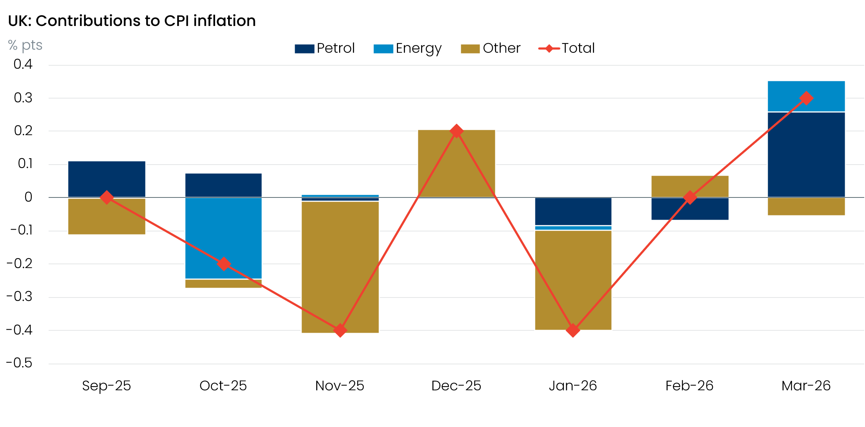
Sources: Oxford Economics, Haver Analytics

April’s S&P Global survey provided some early signs that the increase in fuel prices is already starting to broaden out. Survey respondents reported that a combination of sharply rising input costs and concerns about shortages had led firms to raise prices at the fastest rate in over three years across a wide variety of goods and services.
The impact of higher gas prices on UK inflation is still to come, with Ofgem’s energy price cap on track to rise by around 18% in July. The combination of this upcoming jump in household energy bills and the indirect effects of firms passing on higher input costs, means we expect CPI inflation to reach 4%-4.5% in H2 2026.
Exactly where inflation peaks later this year will be heavily influenced by the scale of April’s once-a-year increases for many index-linked contracts and regulated prices. Collectively, these goods and services account for over 11% of the entire inflation basket, so they play a major role in driving the annual inflation story. We think April’s rise in regulated prices is likely to be smaller than the increase seen last year, but the scale of the price changes is notoriously difficult to predict, so there’s plenty of scope for this source to change the narrative.
Further out, we also anticipate that higher inflation will generate some second-round effects for services inflation via stronger pay growth. However, the scale of any indirect and second-round effects is likely to be much smaller than those seen in the aftermath of the 2022-2023 energy price spike. This is partly because demand remains weak, which limits the ability of firms to fully pass on any cost increases to consumers.
It's also because conditions in the jobs market are much looser than in 2022 and are continuing to deteriorate. This week’s labour market release reaffirmed that message. The ONS reported that headline private sector regular pay growth cooled further in February. Elsewhere, HMRC’s count of payrolled employees contracted again in March, job vacancies edged downwards, and redundancies remained well above long-run averages (Chart 2). Therefore, the ability of workers to push for stronger pay rises to mitigate the rise in inflation looks limited.
Chart 2: The weak picture for job vacancies and redundancies suggests labour market conditions are loosening
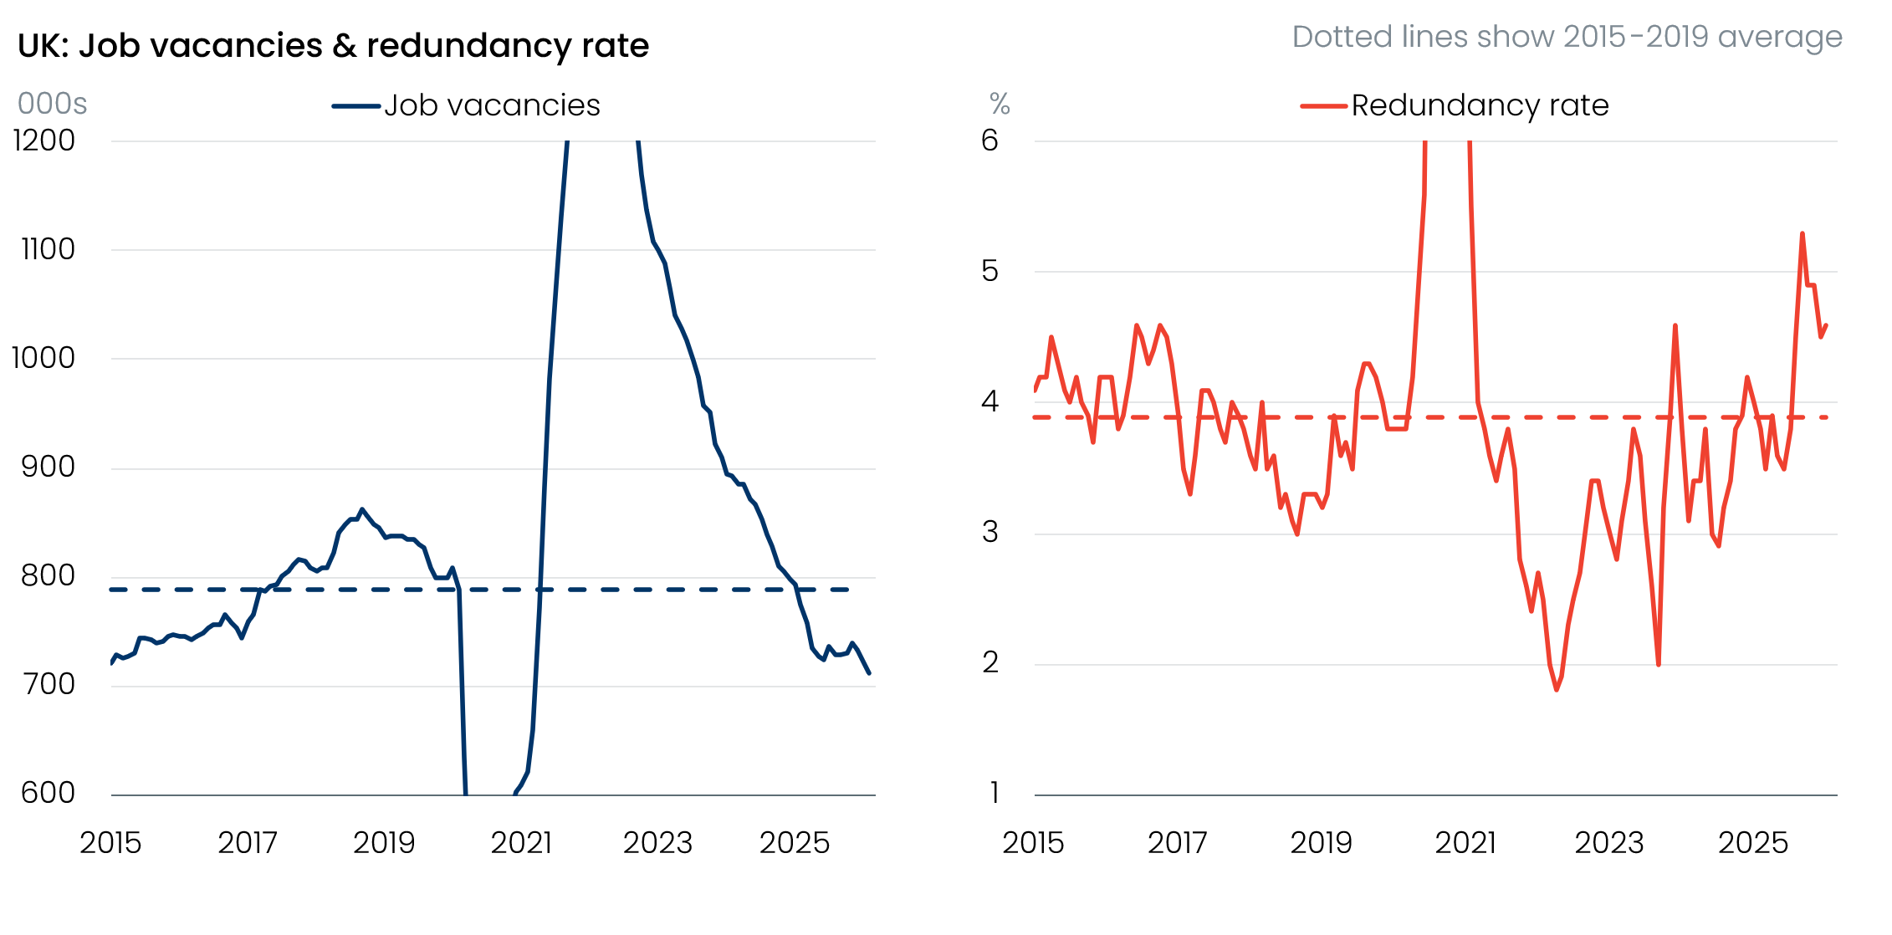
Source: Haver Analytics
We won’t understand the scale of second-round effects until early-2027, when most annual pay deals are set. We expect most Monetary Policy Committee members to use next week’s meeting to signal they’re keen to keep Bank Rate at its current restrictive level as they gather more data about the nature of the energy shock.

The week ahead
The April Monetary Policy Committee meeting is the highlight of next week’s calendar. We expect the MPC to keep Bank Rate unchanged at 3.75%, with most committee members seemingly keen to hold policy at its current restrictive level as they gather more information about how the energy shock is feeding through to the economy. Nevertheless, we suspect a minority will opt for a 25bp hike, on the basis that some pre-emptive tightening is a more robust strategy to guard against an inflation outlook where the risks are skewed to the upside. But stepping back from April’s vote, the real interest will be on how individual committee members use April’s updated forecast and a new set of scenarios to communicate whether majority support for a summer hike is likely to emerge.
Next week also sees the release of the Bank of England’s Money & Credit data for March. Mortgage activity and lending flows remained relatively strong over the first two months of 2026, but the conflict in the Middle East triggered a reappraisal of the monetary policy outlook by financial markets. This pushed up quoted mortgage rates by 40bps-50bps in March and caused a sharp fall in the number of mortgage products available. Therefore, we think there’s a good chance that mortgage approvals slipped back to around 60,600 in March. We expect net secured lending to come in at £3.9bn, down from £4.8bn in February.
On the unsecured side, February’s pickup in consumer credit was entirely due to a normalisation in repayments, as gross lending fell modestly. We expect gross lending to have weakened a little further in March, so we’ve pencilled in a decline in net unsecured lending to £1.8bn, from £1.9bn in February.
Table 1: Week ahead calendar
Date | Events | Period | Measure | Unit | Previous | Forecast
Apr 30 | Nationwide house prices | Apr | m/m | % | 0.9 | -0.3
Apr 30 | Nationwide house prices | Apr | y/y | % | 2.1 | 2.3
Apr 30 | BoE Bank Rate decision | Apr | Bank Rate | % | 3.75 | 3.75
May 1 | Mortgage approvals | Mar | Level | 000s | 62.6 | 60.6
May 1 | Mortgage lending | Mar | Net lending | £bn | 4.8 | 3.9
May 1 | Consumer credit | Mar | Net lending | £bn | 1.9 | 1.8
May 1 | S&P Global manufacturing | Apr | PMI | % bal | 53.6 | 53.6
Source: Oxford Economics

Key forecasts
Table 2: UK forecast overview
(ANNUAL PERCENTAGE CHANGES UNLESS SPECIFIED)
 | 2023 | 2024 | 2025 | 2026 | 2027 | 2028
GDP | 0.3 | 1.1 | 1.4 | 0.6 | 0.8 | 1.7
Private consumption | -0.3 | -0.1 | 0.8 | 0.4 | 0.4 | 1.4
Fixed investment | 0.5 | 1.8 | 4.3 | 0.2 | 1.4 | 2.6
Government consumption | 2.1 | 2.9 | 1.7 | 1.9 | 1.6 | 1.4
Consumer prices | 7.3 | 2.5 | 3.4 | 3.9 | 2.7 | 1.9
Unemployment rate (%) | 4.1 | 4.3 | 4.9 | 5.3 | 5.4 | 4.9
Current a/c balance (% of GDP) | -3.6 | -3.0 | -2.4 | -3.2 | -3.1 | -2.6
Government balance (% of GDP) | 5.2 | 5.2 | 5.1 | 4.2 | 3.6 | 2.9
Central bank policy rate (%, EOP) | 5.25 | 4.75 | 3.75 | 3.75 | 3.50 | 3.00
10yr govt. bond yield (%, EOP) | 3.54 | 4.57 | 4.47 | 4.73 | 4.20 | 3.83
Exchange rate (US$ per £, EOP) | 1.27 | 1.25 | 1.35 | 1.29 | 1.30 | 1.30
Exchange rate (euro per £, EOP) | 1.15 | 1.21 | 1.15 | 1.11 | 1.10 | 1.10
Source: Oxford Economics
Table 3: Quarterly forecasts for the UK
 | 2025 |  |  |  | 2026
 | Q1 | Q2 | Q3 | Q4 | Q1 | Q2 | Q3 | Q4
GDP (% year) | 1.8 | 1.4 | 1.3 | 1.0 | 0.9 | 0.7 | 0.5 | 0.5
CPI inflation (% year) | 2.8 | 3.5 | 3.8 | 3.4 | 3.1 | 3.7 | 4.4 | 4.4
Bank Rate (%, EOP) | 4.50 | 4.25 | 4.00 | 3.75 | 3.75 | 3.75 | 3.75 | 3.75
10yr gilt yield (%, EOP) | 4.70 | 4.48 | 4.70 | 4.47 | 4.88 | 4.80 | 4.79 | 4.73
US$ per £ (EOP) | 1.29 | 1.37 | 1.35 | 1.35 | 1.32 | 1.31 | 1.30 | 1.29
Euro per £ (EOP) | 1.20 | 1.17 | 1.15 | 1.15 | 1.14 | 1.14 | 1.12 | 1.11

Source: Oxford Economics

Latest Country Economic Forecast:
April 20, 2026

Recent publications

Data Insights
March retail bounce too good to be true
Activity growth is likely to slow sharply, despite rebound in April’s flash PMIs
Public finances on track
Surge in fuel prices lifted inflation in March
Jobs data won’t change the MPC’s mind

Research Briefings
MPC preview – Maintaining the ‘wait and see’ message
What different migration profiles mean for the economy and public finances
Why higher rates may be on the MPC's agenda
MPC hunkers down
MPC preview – Middle East war takes March cut off the table

Contacts

Oxford Economics' UK team
- Andrew Goodwin – Chief UK Economist – agoodwin@oxfordeconomics.com
- Edward Allenby - Senior UK Economist - eallenby@oxfordeconomics.com

